**Directors present:**

Henry Bausback, President; John Olenski, Treasurer; Kate Bloomquist, Recorder; Kevin Spence, Shelly Watson, Rita Mann, Richard Parlato, Don Farr, Jacqueline Crouse

**Directors absent:** Leslie Townsend, Kelsie Shy, David Jennings,

With a quorum of 9 Directors established, President Henry Bausback called the meeting to order at 7:10 p.m.

**Guests:** **Candidates for City of Sarasota Commissioner, District #2, Ron Kashden, Liz Alpert**

Both candidates presented their platforms, gave the audience background information on their experience and skills for the job, and took questions from the audience.

**Q and A comments:**

**Official Business Meeting: Kevin moved, Jacqueline seconded to open business meeting.**

**Approval of the Minutes** **for the December 12, 2023, Semi-Annual meeting**:

* Richard moved to approve the minutes of the December 12th, 2023, meeting, as amended.
* Rita seconded the motion.
* All Board members and voting members approved.

**Treasurer’s Report and Membership for the month and year-to-date ending April 30th, 2024**

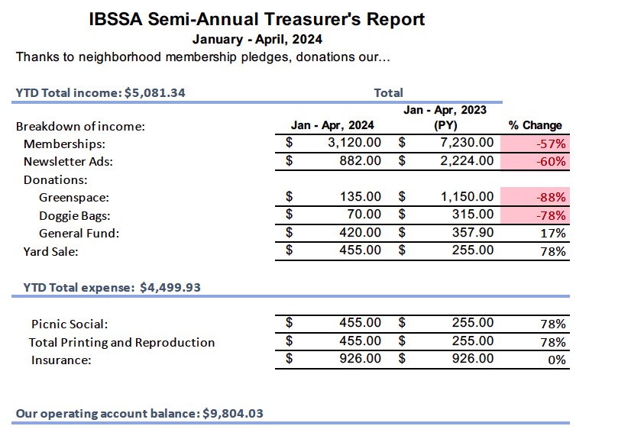

Kate moved to accept the treasurer’s report, all members in favor.

**Committee Report Summaries for 2024**

**Neighborhood Watch Report** (Debbie Muller, read by Kate Bloomquist). In 2023 the City of Sarasota had a 16.2% decrease in Part 1 crimes and no recorded homicides. Our IBSS neighborhood (not including Tamiami Trail addresses) also had fewer motor vehicle thefts (-7) but unfortunately an increase in residential burglaries (+2) and auto burglaries (+3).

This year, January 1-April 30, 2024, is off to an encouraging start with both citywide and IBSS crime being down. Compared to this time last year our neighborhood has had 6 fewer residential burglaries and 10 fewer auto burglaries. Crimes and incidents reported so far this year include: 2 residential burglaries, 1 auto burglary, vandalism of private property, mailboxes and fences, and fruit stolen from fruit trees. Numerous calls have been made to police reporting suspicious persons and vehicles in the area, as well as the police being alerted to the unbecoming and unacceptable behavior occurring at Indian Beach Park. At times this lovely location is a very undesirable area. Suspected illegal drug activity, rowdy persons, fights and overnight camping are some of the concerns. The 40th Street access to the bay is also a problem spot at times with evidence of illicit activity occurring there.

As always, report any suspicious, criminal or potentially dangerous situation to the police. Thank you, neighbors, for keeping our neighborhood safe and family friendly. See It! Hear It! Report It! And please obey the 25-mph speed limit.

**Land Use Committee: (**Kevin Spence) The IBSSA Land Use Committee is tasked to gather information for the IBSSA and residents of our community regarding the present and future planning for development on land within, abutting or impacting IBSS.   
  
Since our last semi-annual meeting of December, 2023 we’ve been focused on two issues:  
1. Roer’s Tamiami, or Calypso apartments, the 224-unit complex with 304 parking spaces on US 41 between 42nd and 45th street.   
2. The vacation of public easements along Corwood Avenue at Bay Shore Road.  
  
Regarding the Calypso Apartments, our contact with Roer’s says the project has run into financing difficulties and they plan to cease development and sell the land. The entire project is assumable, including the purchase of the Super 8, but Roer’s does not anticipate that to happen.   
Regarding Corwood Avenue, the Board and Land Use Committee have come to a compromise agreement with the applicants where easements would remain in place for the land south of Corwood, and IBSSA would not object with the removal of public easements on the North side. Key to our position is that there will be utility easements on the north side that cannot be violated. This position was unanimously accepted by the City Planning Board but still must go before the commissioners this May 20th.

If you would like to stay on top of land use developments and IBSSA positions and actions on these matters, please join our Land Use Interest Email group which also includes invites to attend the LUC meetings; there is a signup at the back of the room and I will be glad to chat after this meeting.

**Beautification/Greenspace Update** (Kate Bloomquist) The Greenway was completed this past year, fenced and seeded for grass. We look forward to using that space for future neighborhood activities. Jack Wooster recently gave the IBSSA sign a complete facelift on Myrtle, at the northwestern corner of the Walgreens parking lot. Other neighborhood signs in the neighborhood will be repainted and planted with native flowering plants. The Charles Hegener Memorial Trail will be the next greenspace to have a cleanup, in cooperation with the City park staff, in late May. Volunteers will get an email to sign up.

**Membership Committee: (**Rita Mann) Our membership is down at this time. Think of all the things that the IBSSA membership funds. We will be sending out a letter to ask residents to renew. If you see your neighbor, ask them if they are currently a member.

| **Topic** | **Update** | **Status** |
| --- | --- | --- |
| Members | As of 5/2 | * 193 |
| Member Communication | New and renewing member updates – continuous  Other member touchpoints: newsletters, social events, clean ups, land use | * Report to board * Communication for new/renewals up to date * To print member letter in new letterhead as well as envelopes |
| Member Experience | Explore options to promote membership through committees, other activities | * -- |
| Board President Letter – all residents (except existing members) so est. 1,000 | * Letterhead design – includes board member names * Week of April 29 – President signed, being printed |
| IBSSA New Resident Welcome Card – new residents | * Design and printer options, get updated list from David for 2023 and 2024 |
| Business Discount Program - members | * Updated list from April posted to website |

**Events Committee:** (Jacqueline Crouse) The 27th was first neighborhood monthly event, a walk to Mama G’s bakery on the campus of New College. 14 people and 4 dogs.

Next event will be dinner at Bacre’s Saturday, May 11, 2024 at 6:45 p.m. RSVP to Jacqueline

jacquelinecrouse@gmail.com

The following event will be Trivia Night at The Mable, Wednesday, June 12, 2024, at 7:15 p.m.

August idea….Happy/Yappy hour, maybe in July 13th at the Greenway?

Another idea may be a yoga event, or kayaking/paddleboarding?

Business meeting officially closed, moved by Shelley Watson and seconded by John Olenski

**Informational Meeting Session:**

**New IBSSA Website Preview:** (Travis Dykes) Travis gave a brief overview of the layout and basic functions for the new website.

**Florida Right to Clean Water:** (Kafi Benz) [ronaturek+rtcw2024@gmail.com](mailto:ronaturek+rtcw2024@gmail.com) New state regulations to put a referendum on the ballot: 900,000 signatures needed in a two-year timeframe. Please let Kafi know if you would like to help.

**Neighbor Comments:**

Regarding the uplands: Kafi presented a brief summary on the campaign (proposed by the new New College president) to make changes to the campus. They are planning to purchase the land on the eastern side of Tamiami Trail, near the airport. The FAA has to approve.

Sarah Hernandez wonders if the change in membership is partially attributed to more AirBnB residences, rather than traditional owner-occupied homes.

Natalie Firnhaber wonders why more neighbors don’t come to our meetings. How can we get the message out?

Liz Barker, running for Sarasota County School Board, District 2. She wanted neighbors to know that she is a mom with kids in our public schools, has been a teacher and school psychologist. [www.lizforsarasota.com](http://www.lizforsarasota.com)

Meeting was adjourned at 8:48

Respectfully Submitted, Kate Bloomquist, Recorder